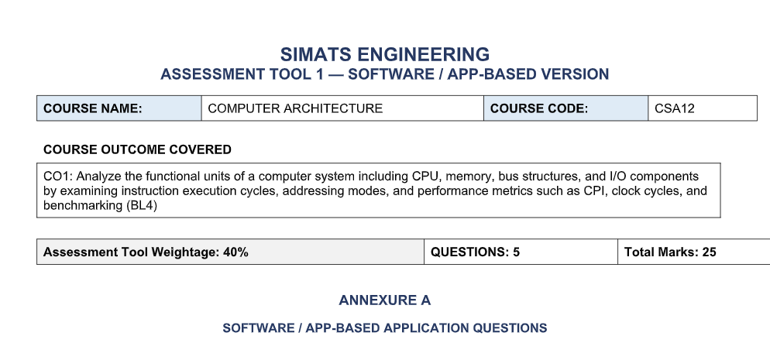
Code of Conduct:
I ______ROSHAN K - 192425014______________ (Name / Reg No) certify that this submission is my original work and that I have adhered to the
guidelines specified for this assessment.
I understand that any violation of academic integrity rules will result in disciplinary action.
Signature of the student: ___ROSHAN K_________________
Each question below is to be answered by configuring, running, or scripting the described scenario in the specified tool — not by written
explanation alone. Submit the tool output (file / screenshot / log) together with the short analytical note requested.

Question 1 (5 Marks)
Topic: Single-Bus vs Multi-Bus Datapath
Scenario: Smart City Surveillance System
Tool: Logisim Evolution
Task
- Build a Single-Bus datapath.
- Build a Multi-Bus datapath.
- Execute the same instruction/data sequence on both.
- Compare timing and throughput.
Deliverables
- SingleBus.circ
- MultiBus.circ
- Screenshot of Single-Bus simulation
- Screenshot of Multi-Bus simulation
- Throughput and latency comparison

Question 2 (5 Marks)
Topic: CPI Improvement
Scenario: Real-Time Stock Trading Application
Tool: MARS or Ripes
Task
- Run the given assembly program.
- Record the CPI from the simulator.
- Optimize the code by reducing:
  - Memory accesses
  - Branch instructions
- Run again.
- Compare the CPI.
Deliverables
- Original .asm file
- Optimized .asm file
- CPI screenshot (Before)
- CPI screenshot (After)

Question 3 (5 Marks)
Topic: 8085 Addressing Modes
Scenario: Industrial Temperature Control Unit
Tool: GNUSim8085 / 8085 Simulator IDE
Task
- Write a temperature-reading routine using at least three addressing modes.
- Execute the program.
- Capture register and memory traces.
- Show correct and faulty data access.
Deliverables
- .asm file
- Register trace screenshot
- Memory trace screenshot
- Short note explaining the faulty addressing mode

Question 4 (5 Marks)
Topic: 8086 Segmentation
Scenario: Multi-Program Execution
Tool: emu8086
Task
- Configure:
  - CS
  - DS
  - SS
- Deliberately misconfigure the stack segment.
- Produce a stack overflow.
- Correct it.
- Run again.
Deliverables
- Faulty .asm file
- Corrected .asm file
- Faulty execution screenshot
- Correct execution screenshot

Question 5 (5 Marks)
Topic: Hexadecimal ↔ Binary Conversion
Scenario: Data Communication System
Tool: Python or Spreadsheet
Task
- Convert hexadecimal to binary.
- Convert binary to hexadecimal.
- Validate the conversions.
- Identify incorrect manual conversions.
- Explain how CPU benchmarking could detect such errors.
Deliverables
- Python script (.py) or spreadsheet
- Output screenshot
- A 3–5 line explanatory note

